|  |
| --- |
| USC Institute for Creative Technologies  12/12/2016 |

|  |
| --- |
| Dan Marino Foundation |
| VITA User Guide |
| December 2016 |



# Contact Information

For assistance or support, please contact:

The Dan Marino Foundation VITA Support Desk

400 North Andrews Avenue

Fort Lauderdale, FL 33301

Phone: (954) 368-6015

Email: [VitaSupport@DanMarinoFoundation.org](mailto:VitaSupport@DanMarinoFoundation.org)

Welcome to ViTA, your Virtual Interactive Training Agent.

 Interviews present a difficult social challenge for everyone and involve a constant need of repeated training and practice. For young adults with autism or other developmental disabilities, the interview training process had a need for a more effective and efficient way to produce better outcomes. With years of research the Dan Marino Foundation and University of Southern California Institute for Creative Technologies developed the ViTA software specifically for individuals with disabilities by using the very latest in virtual reality technologies.  
   
For more information visit www.ViTAdmf.org or email [ViTAsupport@danmarinofoundation.org](mailto:vitasupport@danmarinofoundation.org).

Virtual Interactive Training Agents (ViTA) allows young adults who have Autism Spectrum Disorder to practice job interviews in a safe and configurable environment.

This mod extends the ViTA system to reach a larger audience and provide more relevant and personalized feedback through:

**Adaptive Response Feature**

The Adaptive Response feature will extend the conversational capabilities of the virtual humans and to allow the User’s assigned Instructor an enhanced degree of control in selecting the virtual human’s response. Tasks include redesigning the interaction schemes and creating the new audio recordings, as well as new graphical assets and user interface to support the new functionality.

**Gamification Feature**

The Gamification feature will facilitate the personalization of the ViTA experience with the aim of improving adoption and usage. This includes the addition of personal user profiles that allow for the logging and storing of data (e.g., user status, tracking progress overtime, etc.). Furthermore, dedicated elements aimed to engage the Users will also be added (e.g., achievements). Tasks include integration of learning management system functionality and features.

# DMF Admin: User Profile and Overview

The role of the **DMF Admin** is to support the management of DMF’s Organizations in ViTA and coordinate their creation. The DMF Admin is responsible for correctly inputting the names of the Organizations and their Local Admin point of contact information. The DMF Admin has the ability to change the active status of an Organization, which affects all of its associated users.

DMF Admin Hub - single screen mode recommended 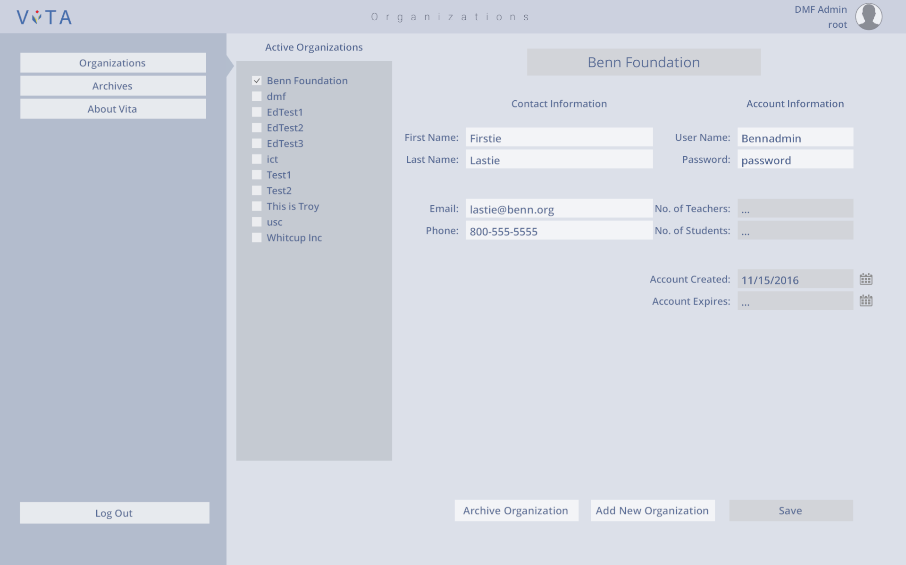

*Organizations*

Create organization: Enter in organization name and its local admin contact information. Ability to edit legal name and password.

*Archives*

Store inactive organizations, reinstate or remove (delete) organizations from ViTA entirely.

# Local Admin: User Profile and Overview

The role of the **Local Admin** is to support the management of DMF’s Teachers, Students, and Classes in ViTA and coordinate their creation for the Organization that they are assigned to. The Local Admin is responsible for correctly inputting the names of the Teachers, Students, and Classes. The Local Admin has the ability to change the active status of a Teacher or Student which affects their associated classes and stored assignment data. The Local Admin also has the ability to assign a Teacher and any Students to a Class.

Local Admin Hub – single screen mode recommended

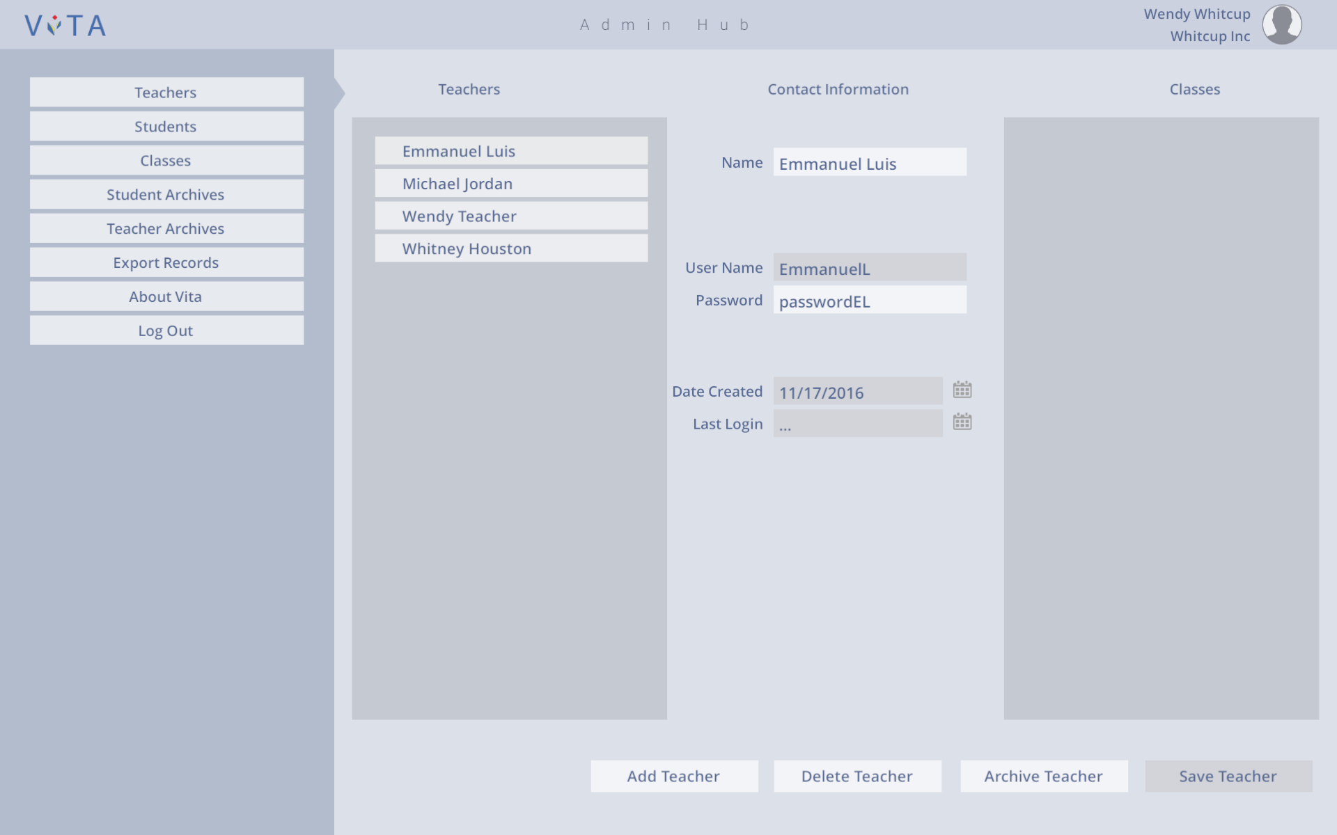

*Teachers*

Create user: Enter in teacher name and login information. Ability to edit legal name and password.

*Students*

Create user: Enter in student name and login information. Ability to edit legal name and password.

*Classes*

Create class: Enter name and assign teacher and students to the class.

*Student Archives*

Deactivate student temporarily or remove/delete from ViTA entirely.

*Teacher Archives*

Deactivate teacher temporarily or remove/delete from ViTA entirely.

*Export Records*

Compile data for students and interview sessions in .csv file format.

# Teacher: User Profile and Overview

The role of the **Teacher** is to organize their classes and monitor their students’ progress. Teachers can manage the assignment of classwork, submit student grades, run Interview Sessions, and submit MIAS scoring. The Teacher has the ability to run Interview Sessions for any student assigned to their class(es) and make notes on their performance before submitting a final MIAS score. Teachers may also view all student progress via Session summaries and graphed data. Teachers create and assign classwork to any of their assigned classes and can view other class assignments and use them as templates. Teachers review and grade the assignments that are submitted by their students and can see the status of any assigned, late, submitted and graded assignments.

Teachers should be aware that the MIAS and grades given to students are reflected in the badges earned by each student.

Teacher Hub – dual screen mode recommended

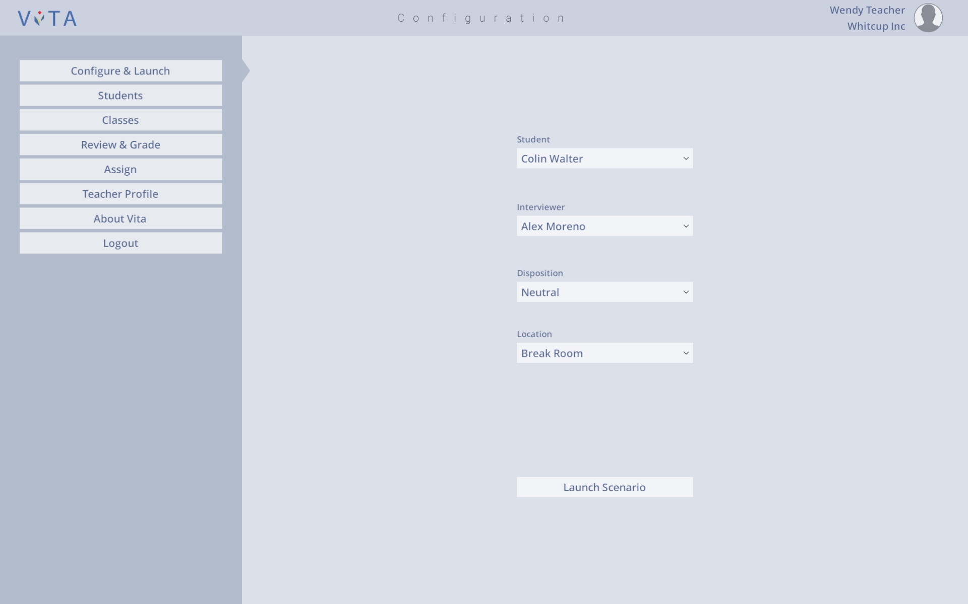

*Configure & Launch*

Run through interview for specific student under a specific scenario.

*Students*

Review Interview Session MIAS score reports via graphs and session summary.

*Classes*

Review currently active classes and which students are assigned to them.

*Review & Grade*

Review status of all assigned work to each student in their class(es). Grade submitted assignments. Cannot review & grade assignments from other teachers.

*Assign*

Create assignments and assignment templates. Review other teacher’s assignments. Assign work to their specific class(es).

*Teacher Profile*

Set “Favorites” for utterance categories on Interview Session. Edit name or password.

# Student: User Profile and Overview

The role of the **Student** is to organize their work and monitor their personal progress for each class. Students can review, complete, and submit assigned classwork from their teachers. Students also have the ability to run through abbreviated Practice Interview Sessions which are not graded. Students may review their earned MIAS scores and Interview Session notes via graphs and comments. The Student may also review their earned Badges for completed tasks like receiving a high grade or MIAS score, unlocking a character, using a new environment, or turning in assignments on time.

Student Hub – single screen mode recommended

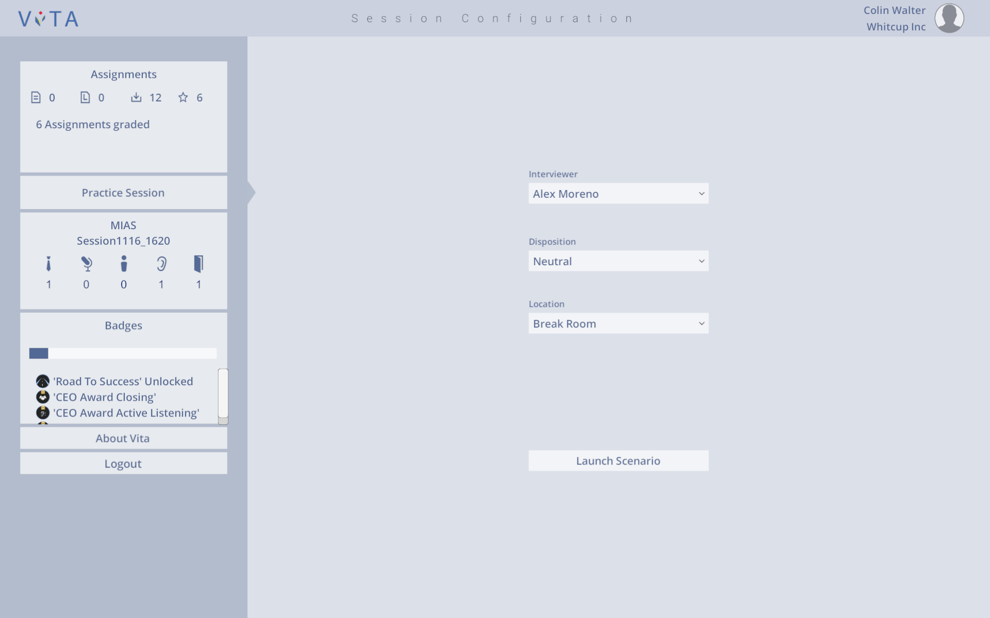

*Assignments*

Review assignments and their current statuses from all teachers and classes. Submit assignment responses. Review graded work.

*Practice Session*

Run through a modified interview session that does not count towards scoring.

*MIAS*

Review all final MIAS scores and Interview Session notes.

*Badges*

Review earned “badges” from completing tasks within ViTA (i.e., homework, interview sessions, logging in, etc.). Review future goals.

*Unlocks*

TBD

# Demo: User Profile and Overview

The role of the **Demo** is to showcase the ViTA features from a Teacher’s perspective. Demo users have the ability to run an Interview Session, insert scoring and comments, and exit without saving the session’s data.

DEMO Hub – dual screen mode recommended

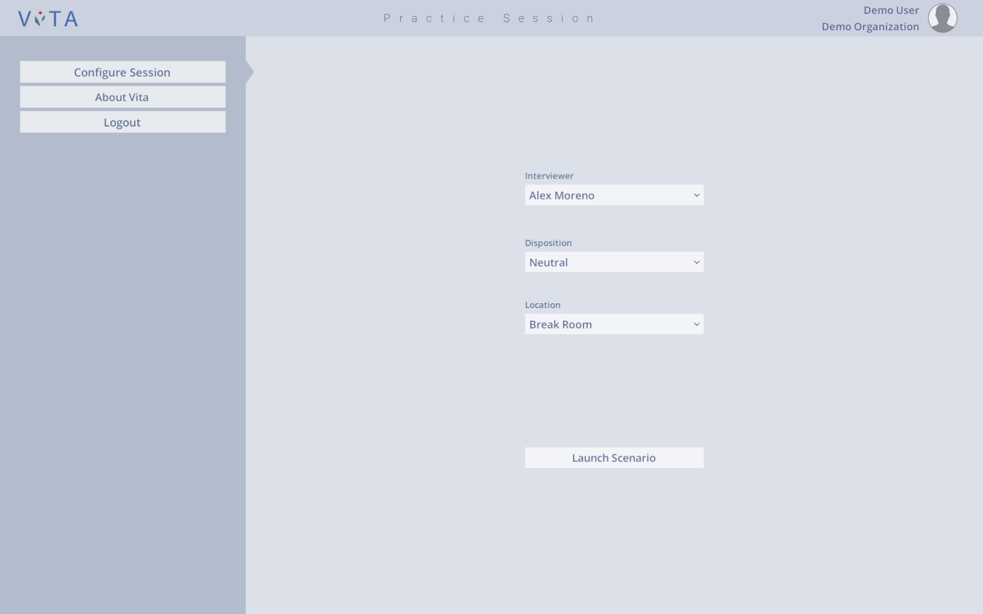

*Configure Session*

Run through interview session from instructor/teacher under a specific scenario for demonstration.

# Install

1. Email received containing link to updated version of ViTA.
2. Click to download.
3. ViTA Setup Wizard will open to guide you through installation. 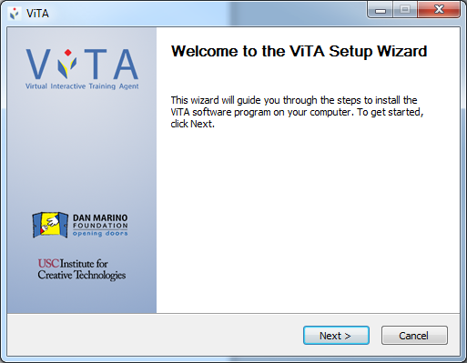
4. File will be saved to C: drive unless other location is specified. 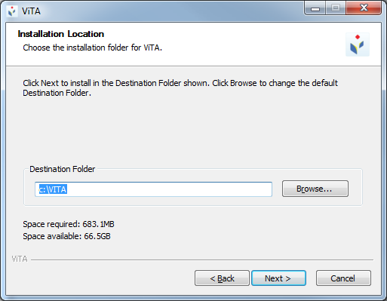
5. You may choose what components to install.

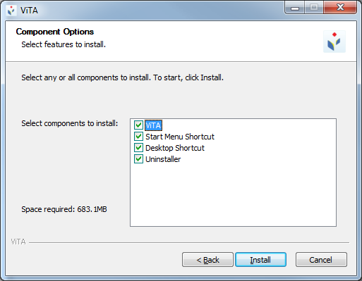

1. You will have the option to launch the ViTA application upon installation.

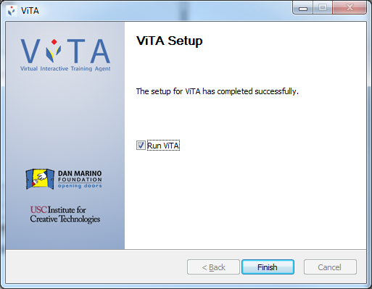

1. One menu shortcut to a dual screen mode of ViTA will be installed onto the desktop.

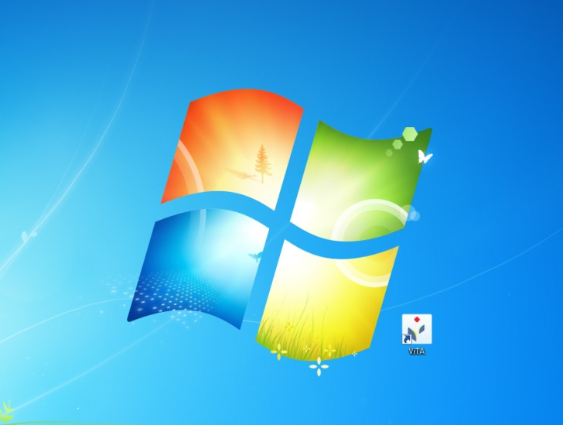

1. The other screen modes can be found under the start menu from which any additional shortcut icons can be made.

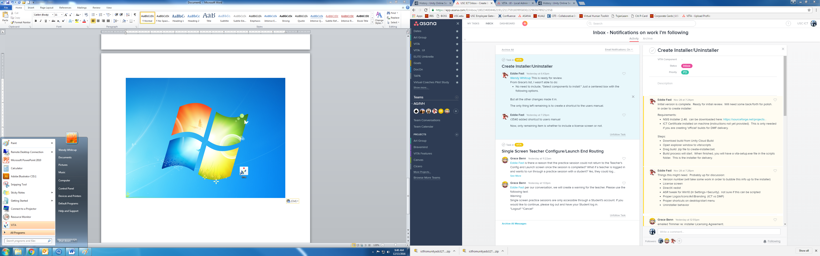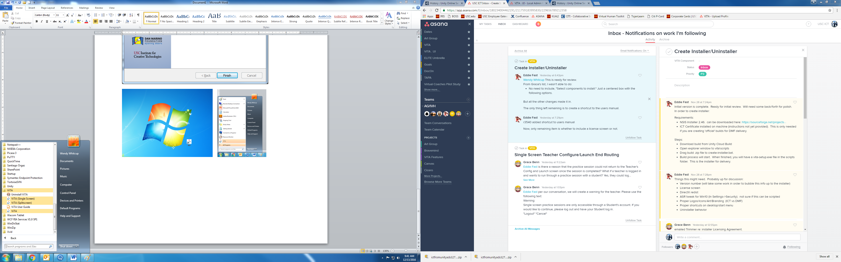

# Uninstall (two ways)

1. Start Menu/Control Panel

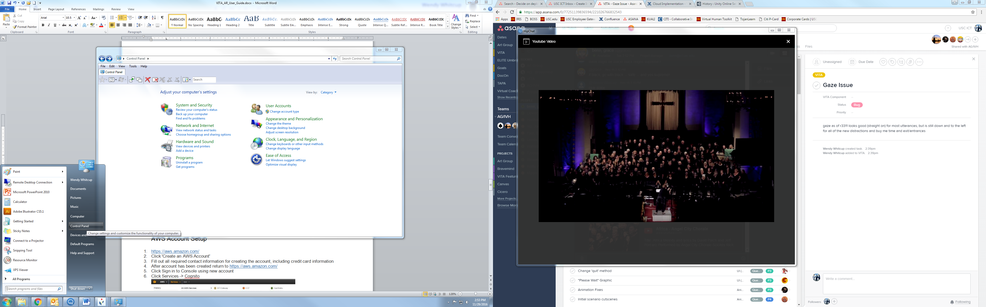

1. Programs. Uninstall a program.

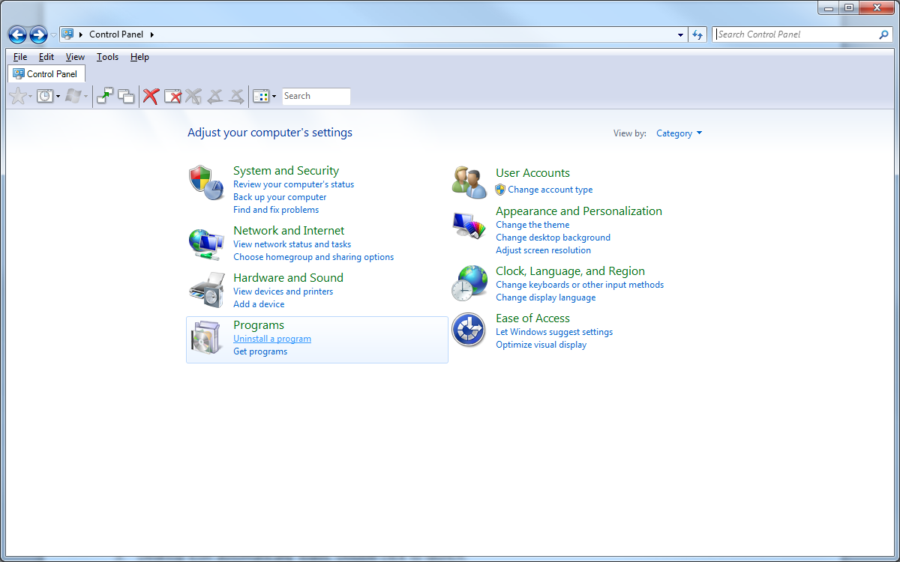

1. Right click Vita. Uninstall.

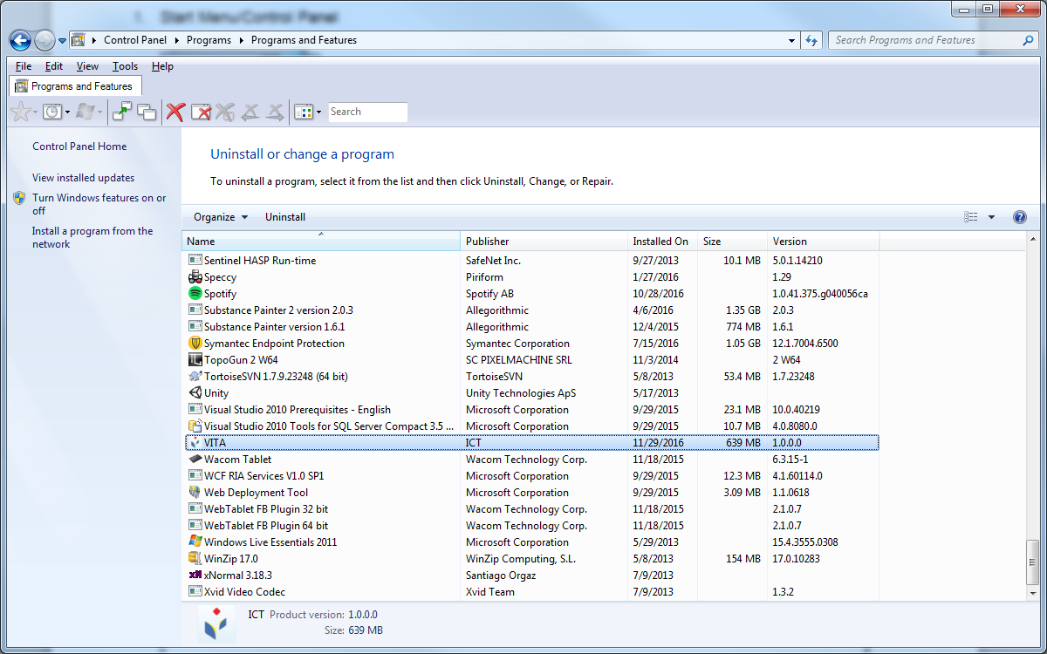

1. Confirm that location where folder was originally saved is cleared of all files.

**OR**

1. Open start menu ViTA and select “Uninstall ViTA”

 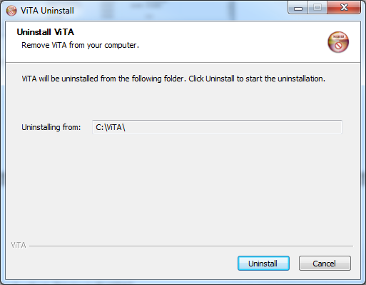

# AWS Account Setup

*Please note: aws.amazon.com updates its system often. Some screen shots may have different buttons or tabs at the time you access the, but in general the directions still apply.*

1. <https://aws.amazon.com/>
2. Click 'Create an AWS Account'
3. Fill out all required contact information for creating the account, including credit card information
4. After account has been created and confirmed by email, return to <https://aws.amazon.com/>
5. Click Sign in to Console using new account
6. Click Services -> Cognito  
   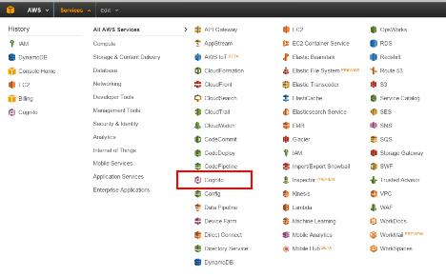
7. Click Manage Federated Identities.  This will bring you to a page that says 'Create new identity pool'
8. Under Identity pool name, enter 'vita'.
9. Click 'Enable access to unauthenticated identities'.
10. Click 'Create Pool'  
    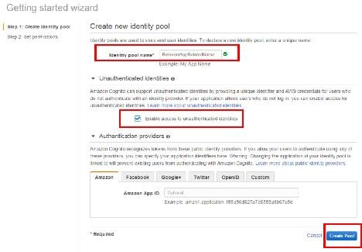
11. Next page will create two IAM Roles, Authenticated and Unauthenticated.  Click Allow.  
    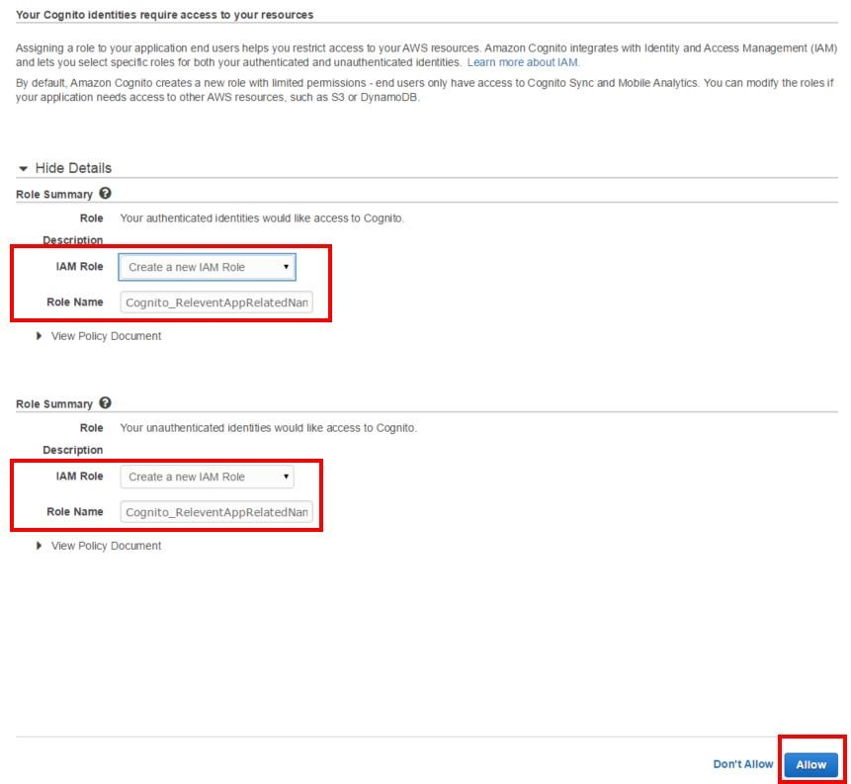
12. Click Services -> IAM.  
    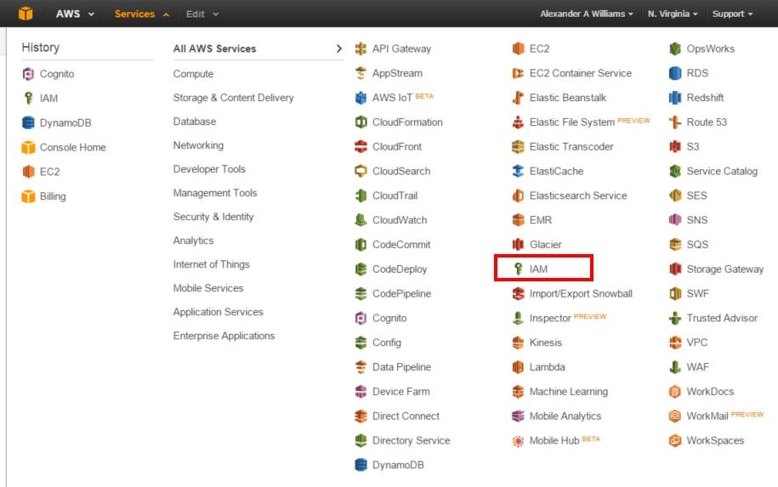
13. Click 'Roles' on the left panel.
14. Click the Unauthenticated Role.  This will show the Summary and Details for the Role.  
    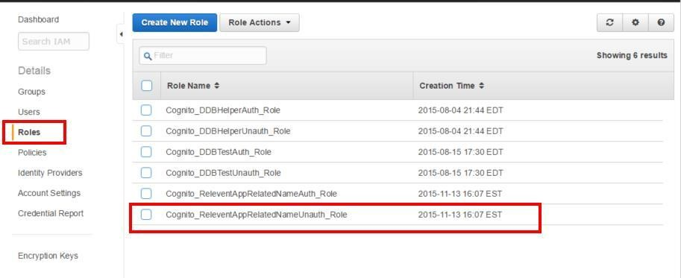
15. Under the Permissions Tab, click Attach Policy.  
    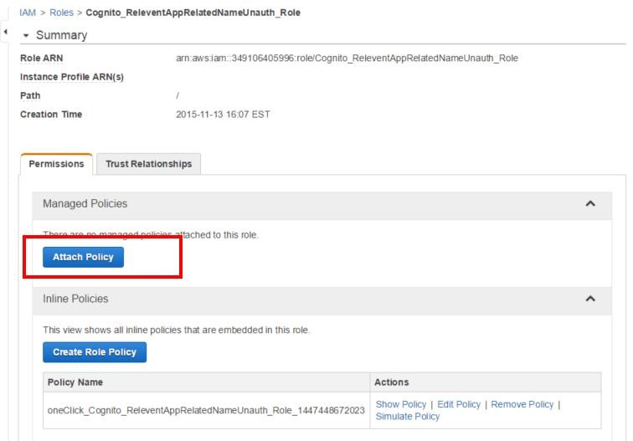
16. Check AmazonDynamoDBFullAccess, then click 'Attach Policy'.  
    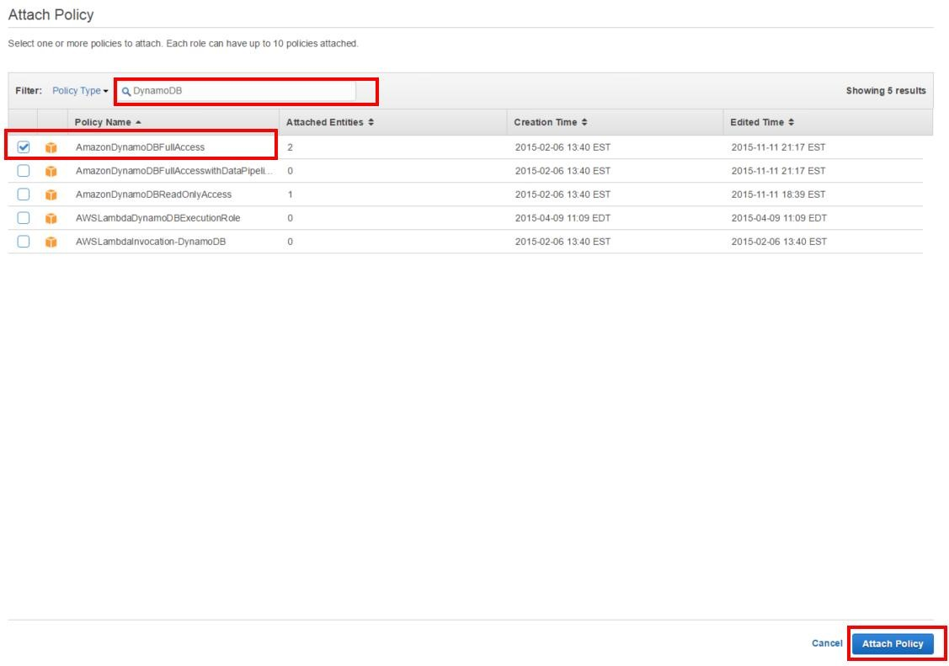
17. Under the Trust Relationships tab, find the connection string, also referred to as the “value”.  It will start with something like us-west-2:<>

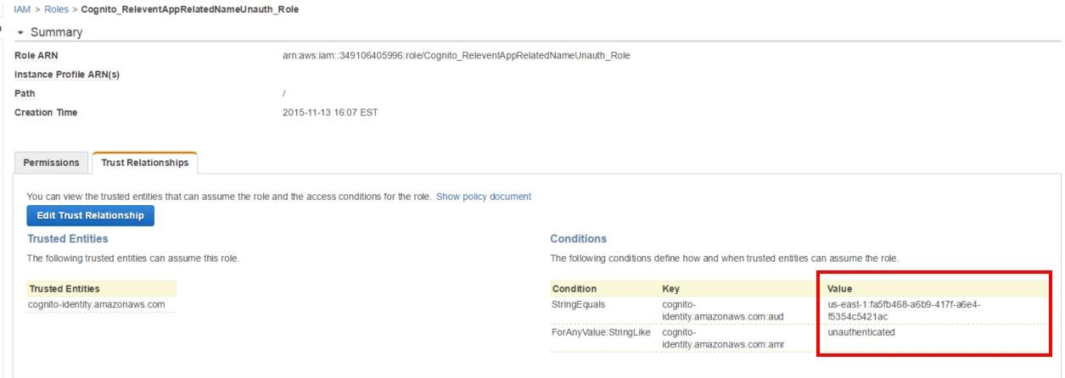

1. Copy this value and email it to ICT to be configured into a new build.  (This is used by VITA to connect to the database).
2. ICT will email you a new build for installation configured to use the new database.

# Reporting Issues

*If the user receives a warning in a pop-up message, please follow the directions given.*

*If further assistance is needed, please contact your System Administrator with the following information:*

1. The login account used when incurring the error
2. The screen on which the error was received (PLEASE NOTE: it is best to provide a screen shot showing the error and screen on which it was received)
3. Any steps taken to reproduce the error (ie. Clicked on a specific button, then another specific button, etc.)
4. The version number of ViTA that was being run at the time of the error (this is shown on the login screen)